**Unit Test definition**

Unit Test (UT) is **code written by a developer** that **verifies the behavior or state** of small element in a software system, which are most often a **single class or methods (the unit)**.

Every UT must have several characteristics (F.I.R.S.)

**Fast**: takes a little time to execute (0.01sec))

.**Isolated**: does not interact with over parts of as system, failure reasons become obvious. (Inversion of Control, Test Double)

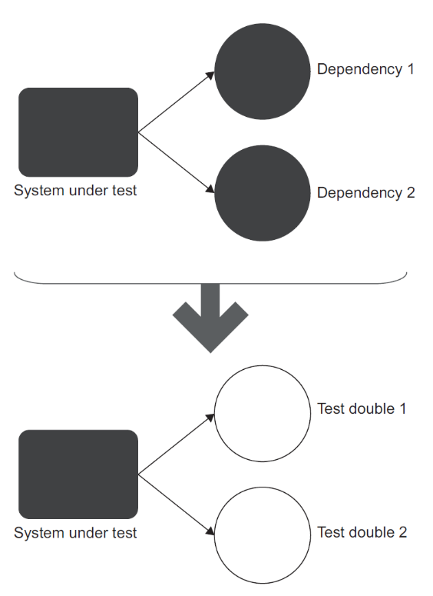

**DEFINITION:** *A* ***test double*** *is an object that looks and behaves like its release intended counterpart but is actually a simplified version that reduces the complexity and facilitates testing.* This term was introduced by Gerard Meszaros in his book, xUnit Test Patterns: Refactoring Test Code (Addison-Wesley, 2007). *The name itself comes from the notion of a stunt double in movies.*

**Repeatable**: run repeatedly in any order, any time.

**Self-Checking**: no manual evaluation required.

**Timely**: written before the code.

**Test is not a unit**

Interacts with over parts of system (DB, API, FS, SMTP, etcs)

Takes to much time to run (more than 0.01sec)

Requires manual setup or verification.

**Unit Test benefit**

Unit test as documentation.

Unit test as safety net (Continues Integration).

Defect localization.

Needless of debugging.

Design improving. (IoC, Refactoring code)

**Effective Unit Test**

It should be automated and repeatable.

It should be easy to implement.

It should be relevant tomorrow.

Anyone should be able to run it at the push of a button.

It should run quickly.

It should be consistent in its results (it always returns the same result if you.

don’t change anything between runs).

It should have full control of the unit under test.

It should be fully isolated.

When it fails, it should be easy to detect what was expected and determine how

to pinpoint the problem.

**Ineffective Unit Test**

When does test become a problem, not a solution?

Fragile Test: break too often.

Erratic Test: sometimes it pass and sometimes if fail.

Manual Intervention: a test requires a person to perform some manual action each time it is run.

Obscure Test: it is difficult to understand the test.

Slow Test: test takes too much time to run.

**Types of tests**

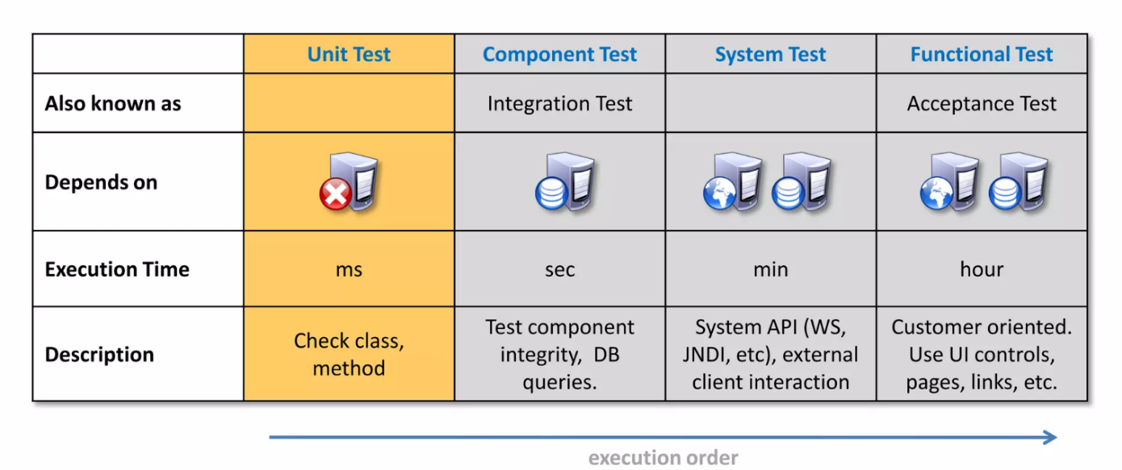

**Test Pyramid**

<https://martinfowler.com/bliki/TestPyramid.html>

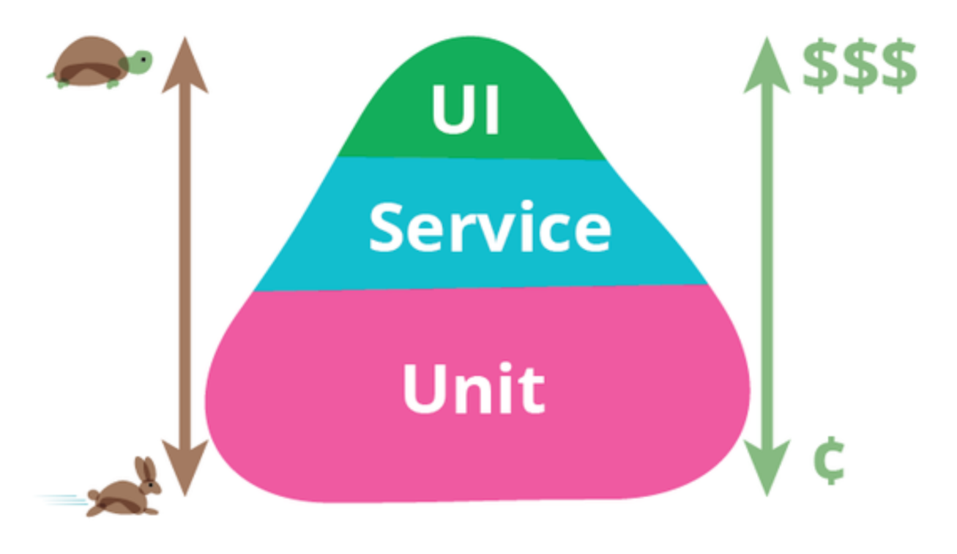

**Integration Test definition (Service Test, Component Test, System Test)**

**Integration Test** is testing a unit of work without having full control over all of it and using one or more of its dependencies, such as time, network, database, threads, random umber generators, and so on.